Week 3 Solution

# Exercise 4: Creating and Configuring a Maven Project

This document outlines the step-by-step setup of a Maven project for the Library Management System using Spring Framework.

## 1. Project Structure

The following folder structure is used to organize the project:  
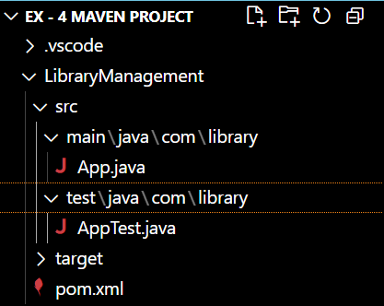

## 2. Creating a Maven Project

Use the following command in terminal to create a Maven project:

**mvn archetype:generate -DgroupId=com.library -DartifactId=LibraryManagement -DarchetypeArtifactId=maven-archetype-quickstart -DinteractiveMode=false**

## 3. Main Java File (App.java)

package com.library;  
  
public class MainApp {  
 public static void main(String[] args) {  
 System.out.println("Hello World!");  
 }  
}

## 4. Add Spring Dependencies and Maven Plugin

Update the pom.xml file with the following content to include Spring dependencies and configure the Maven compiler plugin for Java 2.1:

<project xmlns="http://maven.apache.org/POM/4.0.0"   
 xmlns:xsi="http://www.w3.org/2001/XMLSchema-instance"  
 xsi:schemaLocation="http://maven.apache.org/POM/4.0.0   
 http://maven.apache.org/xsd/maven-4.0.0.xsd">  
 <modelVersion>4.0.0</modelVersion>  
 <groupId>com.library</groupId>  
 <artifactId>LibraryManagement</artifactId>  
 <version>1.0-SNAPSHOT</version>  
 <dependencies>  
 <dependency>  
 <groupId>org.springframework</groupId>  
 <artifactId>spring-context</artifactId>  
 <version>5.3.9</version>  
 </dependency>  
 <dependency>  
 <groupId>org.springframework</groupId>  
 <artifactId>spring-aop</artifactId>  
 <version>5.3.9</version>  
 </dependency>  
 <dependency>  
 <groupId>org.springframework</groupId>  
 <artifactId>spring-webmvc</artifactId>  
 <version>5.3.9</version>  
 </dependency>  
 </dependencies>  
 <build>  
 <plugins>  
 <plugin>  
 <groupId>org.apache.maven.plugins</groupId>  
 <artifactId>maven-compiler-plugin</artifactId>  
 <version>3.8.1</version>  
 <configuration>  
 <source>2.1</source>  
 <target>2.1</target>  
 </configuration>  
 </plugin>

  <plugin>

    <groupId>org.codehaus.mojo</groupId>

    <artifactId>exec-maven-plugin</artifactId>

    <version>3.1.0</version>

    <configuration>

        <mainClass>com.library.App</mainClass>

    </configuration>

</plugin>

</plugins>  
 </build>  
</project>

## 5. Compile the Project

Run the following command to compile the Maven project:

**mvn compile**

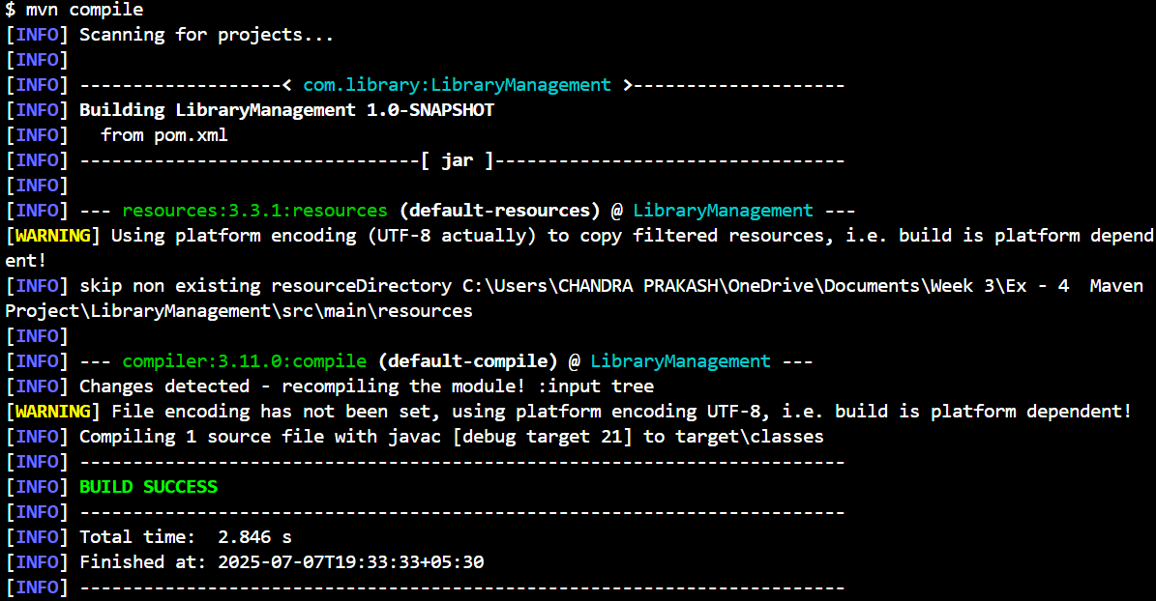

## 6. Run the Main Application

Use the following command to run the application:

**mvn exec:java**

